**OVERSEAS BASED NATIONAL TEAM MEMBERS RAISE BAR OF COMPETITION AT 2015 ISSA HIGH SCHOOLS & COLLEGES MEET GRAY AND WEBLEY CONTINUE AMAZING CAREER WIN STREAKS**

[December 1, 2015](https://draftingthecaribbean.wordpress.com/2015/12/01/overseas-based-national-team-members-raise-bar-of-competition-at-2015-issa-high-schools-colleges-meet-grey-and-webley-continue-amazing-career-win-streaks/) ~ [Tony Morrison](https://draftingthecaribbean.wordpress.com/author/rhinoturtle/)

Eight meet records fell at an exciting but shortened 2015 edition of the Inter Secondary Schools Association ISSA championships on Friday November 27. The meet held at Jamaica’s National Stadium pool was cut short due to poor weather conditions.

A number of Jamaica’s national team members based in the United States took time during the Thanksgiving holiday break to compete at the championships.  Sidrell Williams formerly of Wolmer’s Boys now representing Saint Andrew’s in Boca Raton Florida was responsible for three championship records. He broke the 2003 record of 2:04.34 by Campion’s Matthew Stewart by clocking 2:04.09. Williams set another record in the 17 and over category when he posted 24.60 in the 50 metre freestyle .That bettered the 2006 record of 24.75 set by Garrick Robinson. Williams bettered another Robinson standard in the 100 metre freestyle .The old 2006 record of 58.09 now stands at 56.11.

His teammate at Saint Andrew’s and former Campion College student Jesse Marsh also set a record. His standard was set in the boy’s 15-16 50 metre butterfly where he lowered Williams 2011 mark of 27.75 to 27.50. Marsh also won the 50 metre backstroke in 30.37.

Christian Alberga of Phillips Academy in Massachusetts formerly of Campion College took down his own record in the boys 15-16 100 metre freestyle. He lowered the record from 55.98 to 55.67. He also won the 50 metre freestyle in 25.33

Barak Goren formerly of Campion College now at McCallie in Chattanooga Tennessee won the 17 and over 200 metre individual medley in 2:23.69 as well as the 50 metre backstroke in 31.83.

Bryce Butler of Campion College lowered the 15-16 50 metre breaststroke record from 32.02 to 31.57. The old standard belonged to Kingston College’s Xavier Boland. Boland is a rare athlete having represented Jamaica in both swimming and track and field at both CARIFTA championships in 2012.

Butler’s teammate Emily MacDonald beat the championship record in the girl’s 11-12 50 metre freestyle. MacDonald edged the 2011 mark of Campionite D’Agaene Clarke of 29.20 to post 29.19. MacDonald was also the most prolific winner on the day capturing titles in the 100 metre freestyle 1:05.34, 50 metre breaststroke 41.96, 50 metre butterfly 33.39 and the 200 metre freestyle relay in the meet’s fastest girls time of 2:04.16.Other three time winners on the day included Campion’s Naomi Eaton and Anjuii Barrett in the 13-14 and 15-16 girls age groups respectively and Immaculate Conception High School’s Gabrielle Hopkins in the 17 and over age group.

Octivia Gray of the University of the West Indies UWI was responsible for beating her own standard in the 17 and over 50 metre breaststroke. She lowered the record from 36.46 to 35.91.  Twenty year old Gray has an incredible win streak from her days at the Holy Childhood High School. Gray a former Jamaica national swimmer has never lost this race at these championships. Her streak stretches back to 2007 when she was 12 years old. Octivia has set a record in each age group 12 and under, 13-14, 15-16 and 17 and over. Her team mate at UWI Stefani Webley also has an amazing record at the championships. Webley has this event for the past six years stretching back to her days as a 14 year old at the Immaculate Conception High School.

Immaculate Conception captured the girls title with 420 points. Campion College was 2nd  with 299 points and St Andrew High school for Girls was 3rd with 202 points. The boys title went to Campion College with 316 points. Wolmer’s Boys was 2nd  with 201 points and Jamaica College 3rd with 188 points.  The tertiary title went to the University of the West Indies with 199 points followed by Caribbean Maritime Institute with 173 points.

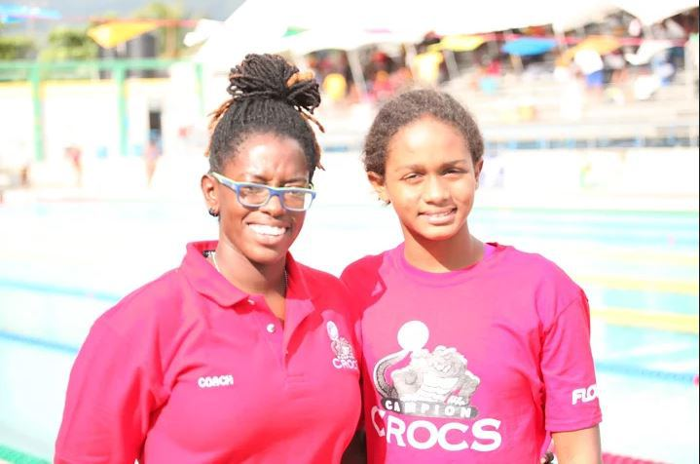Emily MacDonald and Campion College coach Photo courtesy of Lynval Lowe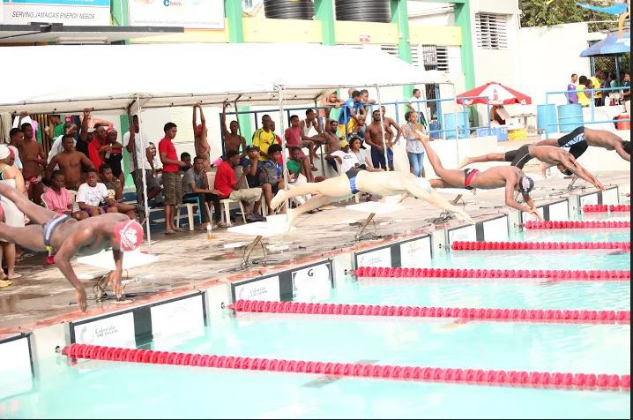Start of the final heat of the boys 15-16 100 metre freestyle Photo courtesy of Lynval Lowe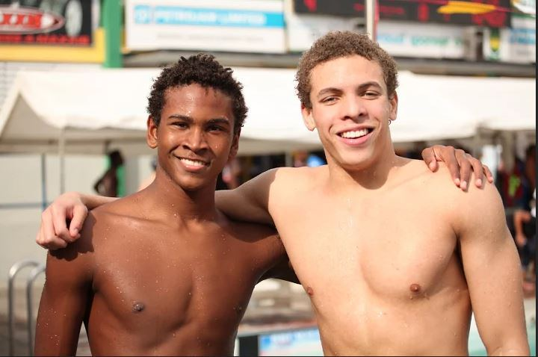left Jesse Marsh of Saint Andrew’s Right Christian Alberga of Phillips Academy Photo courtesy of Lynval Lowe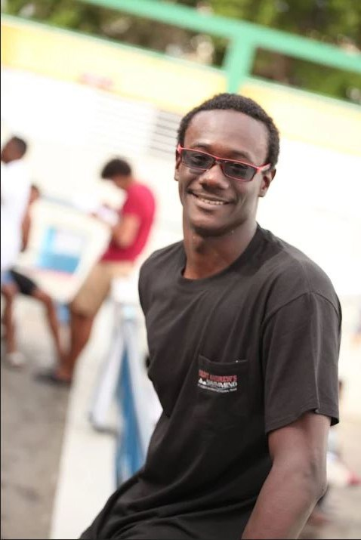Sidrell Williams of Saint Andrew’s Photo courtesy of Lynval Lowe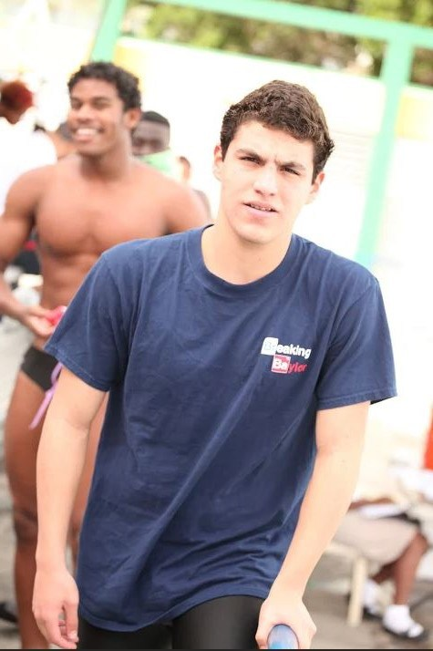Barack Goren of McCallie Photo courtesy of Lynval Lowe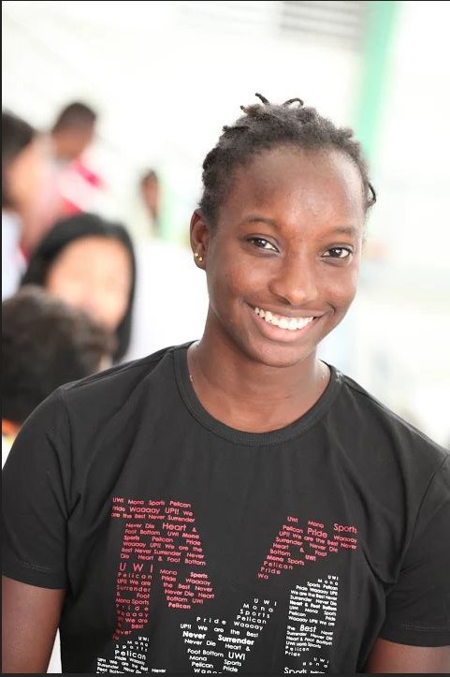Octivia Gray of UWI Photo courtesy of Lynval Lowe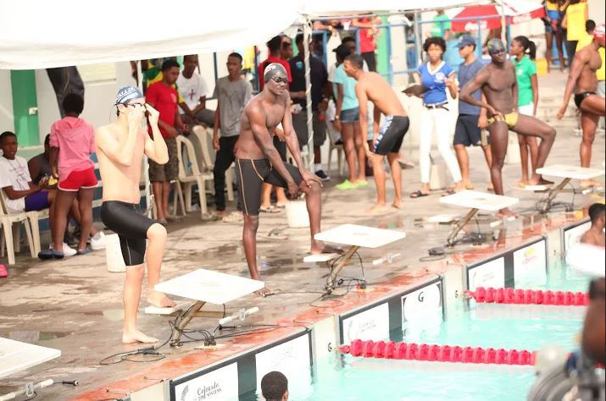Competitors waiting to start the final heat of the boys 17 and over 100 metre freestyle Photo courtesy of Lynval Lowe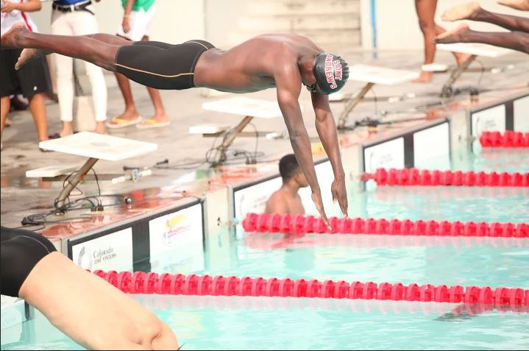Sidrell Williams diving off the blocks Photo courtesy of Lynval Lowe

Stefani Webley

<https://draftingthecaribbean.wordpress.com/2015/12/01/overseas-based-national-team-members-raise-bar-of-competition-at-2015-issa-high-schools-colleges-meet-grey-and-webley-continue-amazing-career-win-streaks/>